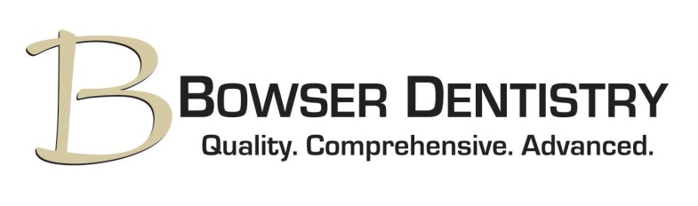
Payment Agreement
Thank you for choosing Bowser Dentistry. We appreciate the opportunity to care for you and your family’s dental needs. The following information is provided to answer questions and avoid confusion regarding payment for dental services.
For patients with dental benefits: As a courtesy, our office will file your claim with your insurance company and work with the company to provide the necessary information to maximize your benefits. Any amount not received from your insurance company is your responsibility. Please take note that there are insurance companies that pay you, the patient. If this is the case, you will be asked to pay at time of service for your treatment.
For patients without dental benefits: If you do not have dental insurance, you will be responsible for the full cost of your treatment. Payment for services is due at the time of treatment unless you have a signed financial agreement.
We accept cash, personal checks and the following credit/debit cards: Visa, MasterCard, American Express and Discover. We also offer no-interest financing plans.
We are pleased to offer a savings to patients with a treatment plan over $500. The treatment must be paid in full on the day of service by cash, check or debit card to receive a 5% savings or by credit card to receive a 2% savings. This savings does not apply to those utilizing Care Credit.
Appointments missed or cancelled less than 48 hours in advance may be charged a $30 fee.
If payment has not been made in full after two statements, a rebilling fee of $10 will be added to each additional statement.
I understand and agree to the above payment agreement.

Signature: ______________________________________________________

Date: __________________________________________________________

